**Mobile Innovations for Global Challenges**

**jQuery Mobile**

Group Members:

Rehan Kadiwala

Kaushik Krishnan

Jie Pang

Sukun Li

**Part 1 – jQuery Mobile questions**

Read the lecture notes on jQuery Mobile.

**Question 1:** What is the difference between mobile native and mobile web development?

**Answer**- Mobile native is basically an app that is developed specifically for that mobile device or a mobile platform (ex. Android & iOS). They are developed in a specific sdk that is suitable for that platform. It has a high performance and quick response time. Users can easily find the apps in the app stores.s

Mobile web development is the web applications or webpages we build that are used on mobile devices. They can be developed using html and eclipse. Development and maintenance is faster. It does not require to be removed from the app store while not using it.

**Question 2:** Provide an example of an app from Google Play developed with mobile web technology.

**Answer**- Youtube, Facebook,

**Question 3:** Provide an example of an app from Google Play developed with native technology.

**Answer-** Google play music, Hangouts

**Question 4:** Provide 4 names of mobile web browsers.

**Answer**- Safari (iOS), Google Crome (Android/iOS/Windows), Mozilla Firefox (Android/iOS/Windows), Opera (Android/iOS/Windows), Flynx (Android), Dolphin (Android & iOS)

**Question 5:** Install Opera Mobile Emulator <http://www.opera.com/developer/mobile-emulator> and access <http://seneweb.com> from it. What do you notice? Explain. Provide at least one screenshot.

It should use more mobile web technology. In a small sreen it displays a lot of data. We have to zoom in to read the text in the website. It should be optimized to display the data according to the mobile device. There is a lot of data in a single page. It should categorize the data so the user can access it easily. The videos in the news don’t work. On a plus point, it is very informative. It also lets you filter the news and search according to your preference

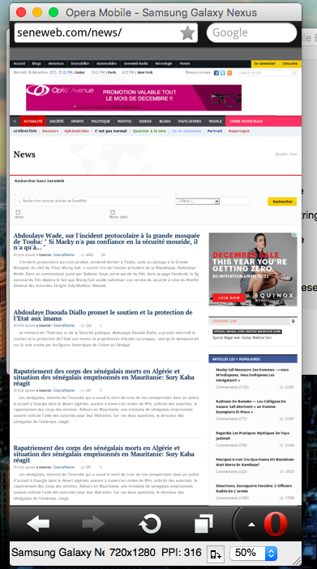

**Part 2 – Develop a jQuery Mobile web site**

Create a mobile web site with jQuery Mobile about AppDock based on the design provided here:

Website url:

<http://webpage.pace.edu/jp00701n/appdock_social/index.html>

github url:

https://github.com/pangjie/appdock\_social

Each team will have a specific app to build. The theme will be based on your team. It will be determined shortly.

Draw the design of the mobile web site and provide us with an image of the design.

Upload the files on webpage.pace.edu and provide us with the url to access it online.

The code should be available in GitHub.

Provide the URL to access your jQuery Mobile web site (webpage.pace.edu or other).

**Part 3 – Package the mobile web site into an app**

You will use Intel XDK to do so.

[https://software.intel.com/en-us/intel-xdk](https://software.intel.com/en-us/intel-xdk" \t "_blank)

The Android app (apk file) should be available in GitHub.

Provide the URL to access the apk file in GitHub.

[**https://github.com/pangjie/appdock\_social\_team**](https://github.com/pangjie/appdock_social_team)